PROJECT NAME
EXPERT REPORT ON QUANTUM, SCHEDULING, OR PROJECT MANAGEMENT
Author: Name and Post-Nominal Letters
Prepared for:
Name of Law Firm

On Behalf of:
Name of Client Line 1
Name of Client Line 2 (If necessary)

Case No. _____________
(Line for additional Case Information)

Delete this Note after Creating Report Depending on the dimensions of your photo, you may need to move down the report date to center it between the photo and the LI logo.
Delete this Note after Creating Report
Use full names (first, middle, and last). For post-nominal letters, only use periods for P.E., P.Eng., Ph.D., and M.B.A., not for CCP, CCE, PSP, etc.
DRAFT
Delete this Note after Creating Report Type the project name and title in all caps.
Use initial caps for author names.
PRIVILEGED & CONFIDENTIAL – ATTORNEY / CLIENT WORK PRODUCT PREPARED IN ANTICIPATION OF ARBITRATION
DD Month YYYY
Table of Contents
1. REPORT TEMPLATE GUIDELINES 1
2. STYLE INSPECTOR AND STYLE PANE 2
3. REPORT LEVEL HEADINGS 3
4. HEADING 1 – TYPE HEADING 1 IN ALL CAPS 4
4.1 Heading 2 – Type Heading 2 in Initial Caps 4
4.1.1 Heading 3 – Type Heading 3 in Initial Caps 4
4.1.1.1 Heading 4 – Type Heading 4 in Initial Caps 4
4.1.1.1.1 Heading 5 – Type Heading 5 in Initial Caps 4
4.1.1.1.1.1 Heading 6 – Type Heading 6 in Initial Caps 4
5. NUMBERED PARAGRAPHS 6
5.1 Numbered Paragraph Sublevels 6
6. EXCERPTS AND QUOTES 7
7. OTHER BULLETED AND NUMBERED LISTS 8
7.1 List Bullet 8
7.2 List Bullet as a Sentence 8
7.3 Dash Under “List Bullet” and “List Bullet as a Sentence” 8
7.4 List Bullets Under a Numbered List 9
8. OTHER GUIDELINES 9
8.1 Miscellaneous Notes 9
8.2 Keyboard Shortcuts 9
8.2.1 Using Hyphens, En Dashes, and Em Dashes 10
8.2.2 Additional Characters and Keyboard Shortcuts 11
8.3 Footnotes 11
8.4 File Names and Footers 12
8.5 Copying Text from Other Documents 12
8.6 Captions for Tables and Figures 13
8.7 Inserting a Table 14
8.8 Inserting a Figure 16
8.9 Adding a Figure or Table That Is Too Small in Portrait Layout 16
8.10 Changing Page Orientation from Portrait to Landscape 17
8.10.1 Adding Landscape Pages 17
8.11 Updating Fields 21
9. CROSS-REFERENCES TO HEADINGS, TABLES, FIGURES, NUMBERED PARAGRAPHS, ETC. 22
10. ADDITIONAL CHECKS 24

To update the Table of Contents, List of Tables, or List of Figures, place the cursor anywhere in the list, right click, and select “Update Field.” Select “Update entire table” or “Update page numbers only” and then click OK.

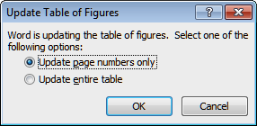

List of Tables
Table 8.7-1: Sample Table 15
Table 8.10-1: Sample Table 19

List of Figures
Figure 8-1: Type a Colon, a Space, and the Figure Title 16
Figure 8-2: JPG with Text Too Small in Portrait Layout 17
Figure 8-3: Type a Colon and a Space After the Figure No. Before Typing the Figure Title (in Initial Caps). To Break a Line into Two Lines, Press Shift + Enter Where You Want to Break the Line. 18

List of Attachments
Attachment 1 Curriculum Vitae of Name and Registrations
Attachment 2 Curriculum Vitae of Name and Registrations
Attachment 3 Title or Description of Attachment
Attachment 4 Title or Description of Attachment
Attachment 5 Title or Description of Attachment
Attachment … Continue as needed

Determine your Attachment numbering styles before you begin your report: i.e., Attachment 1, Attachment 1-1, or Attachment A-1. Type the List of Attachments and List of Exhibits here or paste them from Excel using the “Paste Special, Keep Text Only” command.

List of Exhibits
Exhibit 1 Title or Description of Exhibit
Exhibit 2 Title or Description of Exhibit
Exhibit 3 Title or Description of Exhibit
Exhibit 4 Title or Description of Exhibit
Exhibit 5 Title or Description of Exhibit
Exhibit … Continue as needed

The Lists of Tables, Figures, Attachments, and Exhibits are formatted with the style “Table of Figures.” The hanging indent will need adjustment depending on the type of numbering chosen.

PROJECT NAME

EXPERT REPORT ON QUANTUM, SCHEDULING,
OR PROJECT MANAGEMENT TITLE

REPORT TEMPLATE GUIDELINES
- This document assumes that you are using Microsoft Word, ideally the Office 365 version. If you are using a different version of Word, some of the screenshots in this document may differ from your experience.
- This document provides basic guidelines on how to use the LI Expert Report Template. This document updates previous guidelines; use it for all future reports. These instructions are meant to help you use a standardized format to minimize editing time and client costs. The goal is to make reports easier to create, review, and edit.
- While we do wish to give our reports a consistent appearance, there may be circumstances that justify deviation from this template. In that case, please first discuss specific changes with Richard Long or Andrew Avalon. We may be able to provide a customized template, including approved changes.
- If you see anything in the template that you recommend changing, please let Richard Long know so we can change the template and redistribute it for everyone’s benefit.
- The report template uses one Word file for an entire report. Depending on a report’s size, number of sections, and number of authors, it may be necessary to create a Word document for each section so that various authors can work simultaneously on the report. In this case, it is important that all authors use Word documents with the same styles included in this template. In certain cases, we may create modifications of this template for different sections of a report. Each section would be a separate document. At the top of the first page of each section would be a section number, followed on the next line by the section title.
- It is important to read this document, as it may contain instructions or techniques that differ from your previous experience. If at any point you think it would be helpful, ask Richard Long or the graphics team to walk through some of the basics with your team to ensure that everyone understands how to format our reports with our styles.
- Do not use this document as a report template. Instead, determine whether you need the letter-size or A4-size report template, and use that document. If you do not have the template you need, please request it.

STYLE INSPECTOR AND STYLE PANE
- The following screenshot shows the Word ribbon and ribbon tabs: File, Home, Insert, Draw, Design, Layout, References, Mailings, Review, View, Help, Acrobat, and Picture Format. To display the Style pane, click on the small square with an arrow in the lower right corner of the Style section. This will display the Style pane on the right side of your screen. Click the “Options” link at the bottom of the pane to display “Style Pane Options.” Select “Recommended” and “Alphabetical” from the dropdown menus, make sure all three boxes under “Select formatting to show as styles” are unchecked, and then click “OK.” This will display the recommended LI styles in the Style pane.
- To view the Style Inspector, select the middle icon in the lower left corner of the Style window. If you need to remove a style from part of your document, place the cursor in the line of text and click the “Clear All” button. You can then apply a different style.
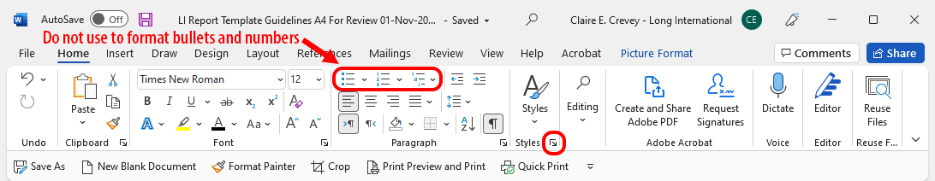
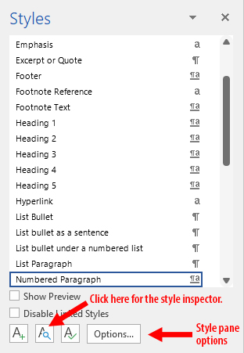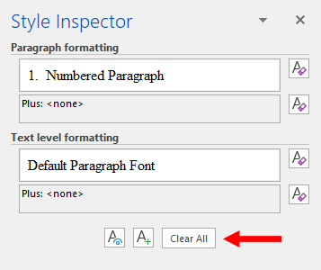
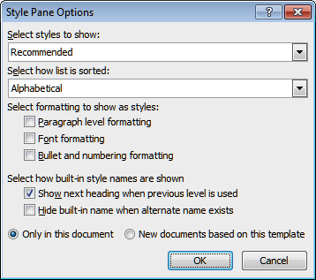

REPORT LEVEL HEADINGS
- The report template includes LI heading styles 1–6. The use of only four heading levels is preferred; the use of the other heading levels is discouraged unless truly needed.
- It is important to first type your headings in the style “Body Text” so you can see your capitalization. Otherwise, capitalization may not appear correctly in the Table of Contents and final PDF bookmarks, even if it looks correct in the body of your document. Use all caps for Headings 1 and 2, and use initial caps for Headings 3, 4, 5, and 6. If you have a Heading 2 title that is very long, we may decide to use initial caps for the Heading 2 style in your report. In this case, that choice will need to be consistent throughout your report and any associated annexes or appendices.
- The styles for Headings 2–6 link to the Heading 1 style, so numbering increments automatically within each section (i.e., 1., 1.1, 1.1.1, … 2., 2.1, 2.1.1, 2.2, 2.2.1, …etc.).
- The heading styles format numbering, indents, and text attributes, i.e., bold, italics, etc. The following section shows how Headings 1–6 look.

HEADING 1 – TYPE HEADING 1 IN ALL CAPS

Heading 2 – Type Heading 2 in Initial Caps

Heading 3 – Type Heading 3 in Initial Caps

Heading 4 – Type Heading 4 in Initial Caps

Heading 5 – Type Heading 5 in Initial Caps

Heading 6 – Type Heading 6 in Initial Caps
- Examples of lowercase words are the, in, to, or, a, an, and for (unless one of these words is the first word in your heading). If you are unsure which words to capitalize or leave lowercase when typing in initial caps, type your header here: https://capitalizemytitle.com/style/Chicago/
- Once you have typed a heading in the “Body Text” style, place the cursor in your heading and select the appropriate heading style. This will update numbering and text attributes.
- If your heading is longer than one line, and you want to change where a line breaks, put your cursor where you want the line break and press Shift + Enter. Delete the space before or after this break because Word creates a space for the manual line break in the table of contents.
- All heading styles automatically insert spacing beneath each heading. Below your heading, begin typing in the “Numbered Paragraph” style. Do not begin text right below a heading with bullets. First, use a lead-in sentence/paragraph to introduce any bullets.
- If the report is a single Word document with multiple sections, each “Heading 1” section should start on a new page. However, there may be exceptions if a section with a Heading 1 is very short or the client wants the report to be as short as possible. In this case, add 36 pts of space above your heading.
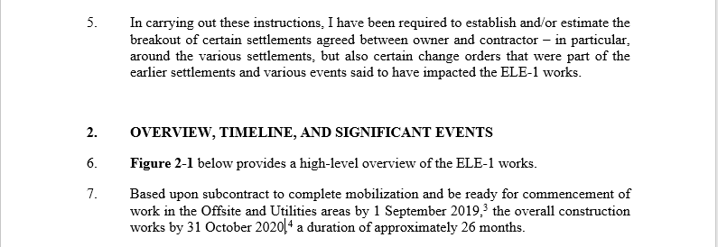
Place the cursor in the Heading 1 and select the small square in the lower right corner of the Paragraph group or right click and select “Paragraph.” Change the space before to 36 pts.
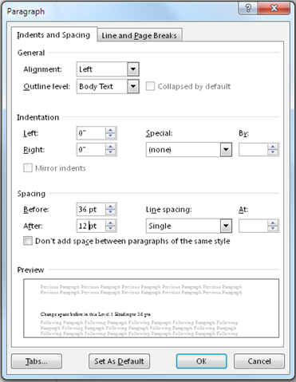

NUMBERED PARAGRAPHS
- This template uses numbered paragraphs, a preferred style for expert reports in U.S., ICC, or other arbitration venues as well as in litigations. The “Numbered Paragraph” style automatically numbers paragraphs, and it inserts a blank line between numbered paragraphs when you hit Enter. Only use this style for numbered paragraphs, not for other numbered lists.

Numbered Paragraph Sublevels
- As you can see in the Styles pane, the “Numbered Paragraph” style has four sublevels:
  - Numbered Paragraph L1
    - Numbered Paragraph L2
      - Numbered Paragraph L3
Numbered Paragraph L4
- Use these substyles for a numerical list within a numbered paragraph. If the items in the list are single words or short phrases, there will be no blank lines between numbered items. Do not use these levels (1, a, i, -) out of sequence or skip a level, such as starting with “a” rather than “1.”
- To access the “Numbered Paragraph” substyles, find them in the Style pane or use promote/demote arrows in the Paragraph group in the ribbon (shown below). Moving text to the right demotes it, and moving it to the left promotes it. Alternatively, with your cursor at the beginning of a line of text, hit Tab to demote or Shift + Tab to promote.
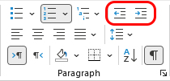

EXCERPTS AND QUOTES
- If a quote is short, insert it within a sentence rather than formatting it as an excerpt. For example: The Minuteman said, “The British are coming.” Use a comma before the quote marks unless the beginning phrase starts with the word “that.” For example: He stated that “The British are coming.” Use smart quotes, not prime marks. Word should create smart quotes rather than prime marks by default. If this is not happening for you, contact the graphics team. For more about quotation marks, see Section 8.2.2.
- For longer quotes, use the “Excerpt or Quote” style, which indents quoted text and puts it in italics. Do not use quotation marks when using this style.
- For quotations, insert the footnote number after the quotation rather than after the sentence that introduces the quotation. For example: AACE International states:
In order for a claimant to be entitled to an extension of contract time for a delay event (and further to be considered compensable), the delay must affect the critical path. This is because before a party is entitled to time-related compensation for damages it must show that it was actually damaged. Because conventionally a contractor’s delay damages are a function of the overall duration of the project, there must be an increase in the duration of the project.
- If you include multiple excerpts from a given reference, and each excerpt comes from a different source document, the footnote would follow each excerpted quotation. Make sure to remove italics from footnotes following italicized quotes.

OTHER BULLETED AND NUMBERED LISTS
- For bulleted and numbered lists, use the recommended Long International bullet and numbering styles listed in the “Styles” pane, not the bullet or numbering icon tools in the “Paragraph” group toolbar.

List Bullet
- The “List Bullet” style is for short phrases or single words, not sentences. Note that list bullets are left aligned with the paragraph text and are not indented:
    - Red hat
    - Blue socks
    - Yellow shirt

List Bullet as a Sentence
- Use this style if a list includes sentences. It adds 6 points of space beneath each item:
The dog is black, and it weighs 150 pounds. It is trying to catch a cat. They are running down the street.
The boy is running after the dog and cat.
    - The dog, cat, and boy are tired.
- Please note that attorneys do not like us to use bullets as it is awkward for them to reference bullets in their legal documents. They prefer the styles shown in 5.1.

Dash Under “List Bullet” and “List Bullet as a Sentence”
- If you want to add a sublist beneath a bullet, use the “Dash under a bullet” style:
    - Shirts
- Green
- Blue

    - Socks
- Black
- Brown
The review of project documents revealed that several warnings did appear in the documentation, which could have led to discovery of the design issues:
- The flare header was designed to have 50 psig back pressure.
- The email cautioned that “the back-pressure can reach as high as 90 psig in the HP Flare Drum and 180 psig at the relieving source.”
- The report noted the potential that the fiberglass piping would potentially overpressure in case of a cooler tube rupture.

List Bullets Under a Numbered List
- The instructions for creating this type of paragraph are as follows:
  - Type a sentence in the style “Numbered Paragraph L1.”
- Choose the style “List bullet under a numbered list.”
- Write an entry.

  - Type the next sentence and select style “Numbered Paragraph L1.”
- Choose the style “List bullet under a numbered list.”
- Write an entry.

OTHER GUIDELINES
- Review the guidelines below to ensure consistency and minimize editing time.

Miscellaneous Notes
- Please note the following miscellaneous instructions.
The letter-size and A4-size templates include preset margins and other page settings. These leave room for the Long International logo that support staff will later insert on all pages, including those in portrait and landscape layouts.
Type two spaces between sentences. The Chicago Manual of Style suggests only one space between sentences, but we prefer the clarity with which two spaces optically separate sentences.
Use American spellings, such as “labor,” not “labour.” Use American punctuation, in which an ending quotation mark follows a comma or period rather than appearing before it.
Put one space after a colon if a list follows. Separate list items within a sentence with semicolons. Otherwise, begin a list on the next line, either with bullets or numbers.
In a series, include a comma before the “and.” For example, “The house is brown, blue, and white.”
    - Italicize i.e., e.g., force majeure, and other Latin phrases.

Keyboard Shortcuts
- Below are common keyboard sequences for special characters. To see whether or not spaces and hyphens are non-breaking, click on the “show/hide paragraph” symbol (¶) in the “Paragraph” group.
Character/Name Key Combination
- Hyphen The hyphen sign is to the right of the “0” key. On a numeric keypad, it is above the + key. The hyphen is the standard symbol to use for minus signs and within document names, as in “Company Doc. No. L290-AB-RFA-10004.”
- Non-breaking hyphen Ctrl + Shift + - [Hyphen sign to the right of the “0” key. Note: This key sequence does not work with a hyphen key on a numeric keypad]. Use this hyphen to keep hyphenated words together so they don’t break at the end of a line of text.
Non-breaking space Ctrl + Shift + Space Bar. A non-breaking space keeps words together so they don’t separate at the end of a line. For example, you can prevent “US$1 billion” from breaking so that “US$1” is at the end of a line and “billion” is on the next line. Insert a non-breaking space between “US$1” and “billion” to keep all the characters together. Use non-breaking hyphens for values and units (as in the example above) and not in document numbers.
– En dash Ctrl + - [Hyphen sign].
— Em dash Ctrl + Alt + - [Hyphen key]. A pair of em dashes can be used in place of commas. Note, however, em dashes are more emphatic than commas. A pair of em dashes can also replace a pair of parentheses.

Using Hyphens, En Dashes, and Em Dashes
- There are three types of dashes: hyphens (-), en dashes (–), and em dashes (—). With some exceptions, do not put spaces before or after hyphens, en dashes, or em dashes. Here is a brief description of how to use these dashes, not intended to be exhaustive.
- A hyphen connects two things that are intimately related, usually words that function together as a single concept or joint modifier (e.g., “tie-in,” “toll-free call,” “two-thirds”). It connects the parts of compound words and document numbers (e.g., seventy-eight, 1000-BBW-555-X-CR-160).
- An en dash represents a span or range of numbers, dates, or pages (e.g., June–August, pp. 178–180). Depending on context, an en dash means “to” or “through.” If you introduce a span or range with words such as “from” or “between,” do not use an en dash. With some exceptions, there should be no space between an en dash and the adjacent material.
- An em dash can function like a comma, colon, or set of parentheses. The most common uses of em dashes are to bracket parenthetical information and to add emphasis. This can add flair and energy to your writing—a dash (aha!) of drama. It allows, in a manner similar to parentheses, adding a thought within a sentence by sort of breaking away from that sentence—as done here.

Additional Characters and Keyboard Shortcuts
° Degree symbol Ctrl + @
§ Section mark Ctrl + Alt + 6
¶ Division Ctrl + Alt + 7
… Ellipse Ctrl + Alt + .
© Copyright symbol Ctrl + Alt + C
® Registered symbol Ctrl + Alt + R
™ Trademark symbol Ctrl + Alt + T
“text” Double Smart Quotes Shift + Quotation Mark Key. Use for quoted material when not using the “Excerpt or Quote” style. Example: He stated, “The defects were serious.”
‘text’ Single Smart Quotes Quotation Mark Key. Use single quote marks for quoted material within quoted text. Example: “When I say ‘immediately,’ I mean today,” he said.
" Double Prime Mark Shift + Quotation Mark Key, and then immediately type Ctrl + z to change a double smart quote mark (”) to a double prime mark ("). Use the double prime symbol in measurements: 2" means 2 inches. A smart double quote (2”) is incorrect. Note: Spell out “inches” and “feet” in your report, but prime marks are acceptable in tables to save space.
' Single Prime Mark Quotation Mark Key, and then immediately type Ctrl + z to change a single smart quote mark to a single prime mark. 5' means 5 feet. A smart single quote (5’) is incorrect.
Manual Page Break Ctrl + Enter (on a keyboard or a numeric keypad) inserts a manual page break.
“i.e.,” and “e.g.,” Latin abbreviations: “e.g.” means “for example,” and “i.e.” means “that is.” These should be italicized, and a comma follows the period.

You can find additional symbols and special characters in the “Insert” tab. Go to the “Symbols” grouping on the right, click on the “Symbol” icon, and select “More Symbols…”

Footnotes
- Footnotes follow punctuation, meaning after the period at the end of a sentence, with no space before the footnote. Word inserts the footnote where you have the cursor and adds the footnote number at the bottom of the page. Always type your footnote number in roman (plain) font, not italicized or bold.
- To insert a footnote:
  - Place your cursor where you want the footnote to appear.
  - In the “Footnotes” group of the “References” tab, select “Insert Footnote.”
  - A footnote number will appear in the location of your cursor and at the bottom of the page. The style for the superscript footnote number is “Footnote Reference.” The style for the citation information in the footer is “Footnote Text.”
- Long International does not have detailed footnote formatting guidelines because citation styles change from one report to another for a variety of reasons and often even change during the progress of a single report when the client makes new requests. Therefore, just doing your best with footnote formatting is the best approach.
- Within footnotes, there are different ways to format an Appendix or an Exhibit Number. This will be decided and agreed upon for each report. Once this format is established, be consistent throughout the report.
- See below for an example footnote from a previous report. Note the en dash indicating a range, the use of “para.” rather than “paragraph” or the ¶ symbol, and the use of “p.” rather than “page.” For multiple pages, type “pp.” Also note that the footnote ends with a period, then two spaces, then the exhibit number in brackets and bold.

File Names and Footers
- In your Word file names, type your project number, the report title, your initials, and the date. Subsequent reviewers will add their initials and update the date. Follow this convention for all drafts; support staff will clean up the footers in the final version. Below are file name examples for first and second drafts:
413 SLC Sewer Response Report RJL 19-Oct-2021
413 SLC Sewer Response Report RJL DJN 21-Oct-2021

Copying Text from Other Documents
- If you copy text from another document to use in a report, use “Paste Special” from the Clipboard group on the Home tab. Place the cursor in a blank line and select the style you want to use for the paragraph, i.e., “Body Text,” “Numbered Paragraph,” etc. Go to the drop-down arrow under “Paste,” select “Paste Special,” and select “Keep Text Only.” This will prevent styles from other documents coming into your report.
- The reference document may include tables, graphics, footnotes, and complex numbering and formatting. It may be necessary to copy and paste this text with formatting, rather than trying to format the excerpted text. Please contact Richard Long or the graphics team for assistance with this.

Captions for Tables and Figures
- Agree on your table and figure numbering before beginning a report. Your numbering will be based on Heading 1 or 2. Note: Word does not allow you to use both Heading 1 and 2 numbering options at the same time in a document.
  - The “Caption” style creates sequential numbering for each figure and table based on the heading level selected. This allows Word to update table and figure numbers when you update the file rather than someone having to renumber previously created tables or figures manually if you add or remove a table or figure.
  - The simplest approach is to base numbering on Heading 1. Each table or figure becomes 1-1, 1-2, 1-3, etc. within each section.
  - If you base numbering on Heading 2, you need to be more careful. Each table or figure becomes 1.1-1, 1.1-2, 1.1-3, etc. In this case, if a section has no figures or tables, the section still needs a Level 2 heading for numbering to work properly in other sections. You can insert a Level 2 heading as “hidden text” that will not appear in the Table of Contents. Type your Level 2 heading as “Hidden text for numbering.” If you see these words in your Table of Contents, then they are not accurately hidden. To hide text:
- Select the text you want to hide.
- Right click in the text and select “Font.”
- Check the box for “Hidden” under “Effects.”
- To insert a figure or table number and title, go to the References tab and click “Insert Caption.” Select “Figure” or “Table” from the “Label” drop-down menu. Click on the “Numbering” button and select a heading level and “- (hyphen)” from the drop-down menus. Click OK. Type a colon, a space, and a title after the figure or table number.
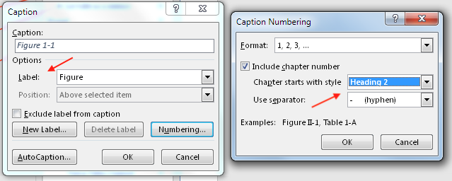
- To learn more about captions in Word, visit https://support.microsoft.com/en-us/office/add-format-or-delete-captions-in-word-82fa82a4-f0f3-438f-a422-34bb5cef9c81

Inserting a Table
- Agree on your table and figure numbering prior to starting a report.
- You can add a table to a report in three ways: (1) create the table in Word, (2) copy and paste a table from Excel, or (3) insert a screenshot of a table. Creating tables in Word is preferred so they are responsive to the Word spell checking and LI formatting.
- To create a table in Word:
  - For the table title, format a blank line of text with the “Caption” style. Then go to the References group on the ribbon and select “Insert Caption” in the Captions group. This will create a table number based on contextual heading and section numbers. Every other table you label with the “Caption” style will automatically receive its appropriate number.
  - Following the generated table number, type a colon, a space, and the table title. Center this text on the page. The List of Tables will automatically capture text formatted with the “Caption” style.
  - If your table needs a subtitle, use the style “Table or Figure Subtitle” to add additional information. The List of Tables does not capture the subtitle style. If you add a subtitle, then delete the excess space between the table title and subtitle: click in your table title and select the small square in the lower right corner of the Paragraph group or right click and select “Paragraph.” Change the space after to 0 pts.
  - On a blank line, select the “Table Data” style. Using “Table” in the “Insert” tab, insert a table with the number of rows and columns you require.
  - Your table should automatically have the table style “LI Table.” This will give it a teal header row and other features. If you ever need to apply the LI table style, click on your table and find the style in your table design options in the ribbon.
  - Set each column to an appropriate alignment. For example, see the table below, in which the first column contains categories, so it is left-aligned, and columns that contain numbers are right-aligned.

Table 8.7-1: Sample Table
This is the “Table or Figure Subtitle” style above a table created in Word.
 | 2008 Total  (7 Months) | 2009  Total | 2010  Total | 2011  Total | Grand  Total
Cash Flow as IL Facility | ($463,063) | $306,420 | $2,978,260 | $3,646,166 | $6,467,783
Less: Conversion Costs | (702,676) | (1,073,460) | 0 | 0 | (1,776,136)
Net Cash Flow | (1,165,739) | (767,040) | 2,978,260 | 3,646,166 | 4,691,647
Net Impacted Cash Flow | (199,872) | (531,741) | (729,795) | 135,570 | (1,325,838)
Reduced Operating Cash Flow | (965,867) | (235,299) | 3,708,055 | 3,510,596 | 6,017,485
Discount to Net Present Value | 0 | 0 | (248,216) | (641,024) | (889,240)
Prejudgment Interest | 3,962 | 6,533 | 359 | 0 | 10,854
Reduced Operating Cash Flow | ($961,905) | ($228,766) | $3,460,198 | $2,869,572 | $5,139,099
  - To facilitate creating a new table, you can copy the table number, title, and table from this document and paste them into your document using “Keep Source Formatting” from the clipboard. Update the table number by right clicking on it and selecting “Update Field.” Add additional rows or columns as needed. If you have questions, contact Richard Long or the graphics team.
- You can also copy and paste a table from Excel, providing it is not too large. After pasting it into Word, style the content as “Table Data.” Change column alignment and text attributes as necessary. Note: To show/hide table cells, click in the table and select the Layout tab under the Table Tools tab and select “View Grid lines” in the Table group.
- If you paste in an image that looks like a table, label it a table, not a figure. Place a footnote at the end of the table title to indicate the source document. Alternatively, enter the source under the title, on a line styled as “Table or Figure Subtitle.”
- If you insert a screenshot from Excel, please format your header row in Excel with the color circled below:
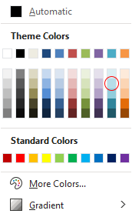

Inserting a Figure
- To insert a figure (JPG or PNG) into a report:
  - Use the “Caption” style to generate a figure number. The List of Figures will capture this style. Type a colon and space after the figure number, then add the figure title. Type a return, and space below the title appears automatically.
  - If the figure has a subtitle, format it as “Table or Figure Subtitle.” Type a return. A space below the subtitle appears automatically. Immediately type two returns. The two new lines will be automatically formatted as “Space behind/after a Graphic.”
  - Place your cursor in the second blank line under the title or subtitle, go to the “Insert” tab, select “Picture” from the “Illustrations” group, and navigate to the location where the figure JPG or PNG is located.
  - Click on the image and select the “Insert” tab. Adjust the size of the JPG or PNG as necessary.
  - Use the style “Table or Figure Subtitle” to add additional information about the figure if necessary. The List of Figures does not capture the subtitle style.
  - An example of a figure with a subtitle is shown below:
Figure 8-1: Type a Colon, a Space, and the Figure Title
This subtitle is in the style “Table or Figure Subtitle.”
Below the figure, the style is “Space behind/after a Graphic.”
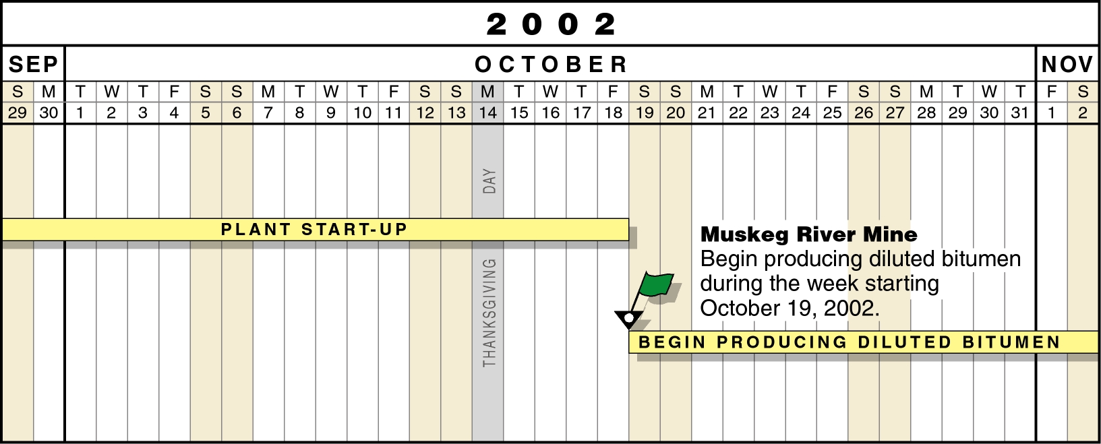

Adding a Figure or Table That Is Too Small in Portrait Layout
- If your image is too small in portrait layout (see below), you can change the page orientation to landscape layout. This may also apply to large tables you create in Word. The following procedure shows how to add a page in landscape orientation.
Figure 8-2: JPG with Text Too Small in Portrait Layout
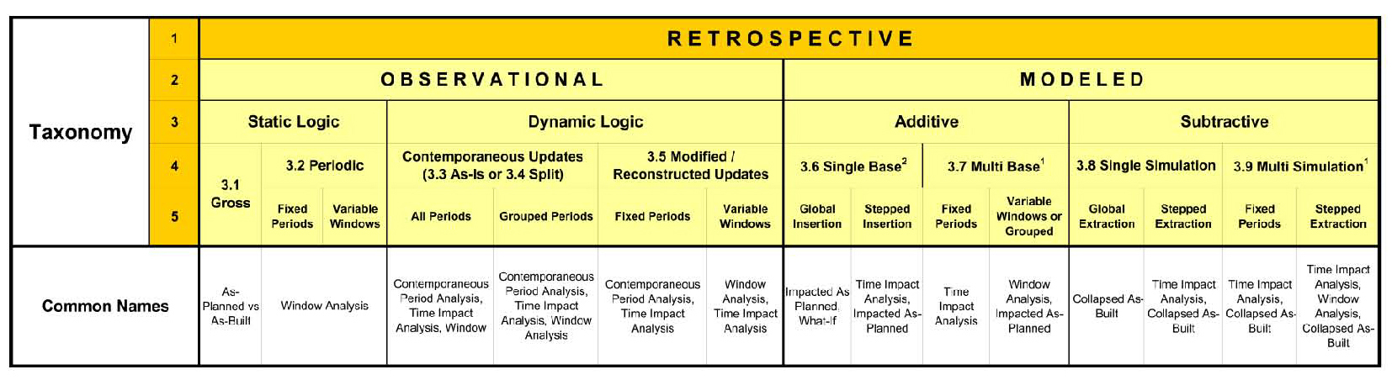

Changing Page Orientation from Portrait to Landscape

Adding Landscape Pages
- To add a page or pages with a landscape orientation, follow the procedure below.
  - Select everything from “START COPY” through “END COPY” and select Copy or press Ctrl + c.
  - Go to the location in the document where you want to insert a landscape page.
  - With the cursor at the top of the page, select Paste or press Ctrl + v. This will add a landscape page with one-inch margins on all sides.
  - After inserting the page or pages, delete only the “START COPY” and “END COPY” lines. Do not delete the section breaks (which are hidden text; press the ¶ icon in the Home tab ribbon to see them) immediately below “START COPY” and above “END COPY.”
  - See instructions on the next page to add additional landscape pages.
  - Sample landscape pages with tables with notes are included to facilitate adding larger tables.
  - Please contact Richard Long or the graphics team with questions.

- - - - - - - START COPY - - - - - - -

Figure 8-3: Type a Colon and a Space After the Figure No. Before Typing the Figure Title (in Initial Caps).
To Break a Line into Two Lines, Press Shift + Enter Where You Want to Break the Line.
If you are placing a table on the landscape page, insert a caption using Table instead of Figure.

Delete the sample image above and insert a new image. If you insert a multi-page table, the table number and title appear only on the first page.

Do not delete the section break. This would convert additional portrait pages to landscape. To view the section break, click on the “Show/Hide paragraph marks symbol ( ¶ ) on the Home tab, in the Paragraph group.

If you need additional landscape pages, place the cursor immediately below this text and use the “Page Break” icon in the Pages group of the Insert group or type Ctrl + Enter to add the number of pages you need.

Table 8.10-1: Sample Table
This Table is created in Word. Not all tables need subtitles.

Line 1  Line 2 | Line 1  Line 2 | Line 1  Line 2 | Line 1  Line 2 | Line 1  Line 2 | Line 1  Line 2 | Line 1  Line 2 | Line 1  Line 2 | Line 1  Line 2 | Line 1  Line 2

Add or delete rows and columns and adjust column widths as necessary.

If the table extends over multiple pages, the header row will appear at the top of each page. You can paste data from Excel in the table above by using “Paste Special,” “Keep Text Only,” only if your Word table has the same number of rows and columns as the Excel table (e.g., both tables are 12 columns wide and 25 rows high).

If size makes this approach impractical, the Excel table can remain in Excel, be printed as a PDF file, and be inserted as an attachment.

Blank Landscape page

- - - - - - - END COPY- - - - - - -
- You will need to adjust header spacing and page numbering on portrait pages following an inserted landscape page or pages. Double click in the header to see the ribbon shown in the screenshot below. Change the “Header from Top” value to 1.3". Leave the “Footer from Bottom” value at 0.5".
- Click on the “Go to Footer” icon in the header and footer tools. Click on the “Page Number” icon and select “Format Page Numbers” from the drop-down menu. Select “Continue from previous section” and click OK.
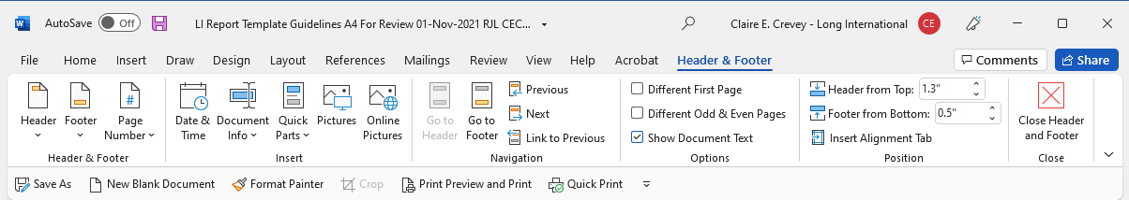

Updating Fields
- To update all fields in a document, including cross references, captions, the table of contents, the list of tables, and the list of figures, place your cursor somewhere in the document text, press Ctrl + A to select all text in the document, and then press F9. You will see a series of windows like the ones below. For each window that appears, select “Update entire table” and press OK.
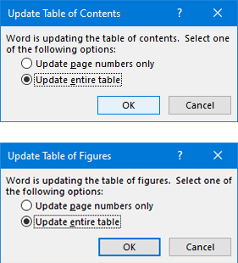
- When you press Ctrl + A with your cursor somewhere in the main text of your document, footnotes are not selected. To update any fields that may be included in the footnotes, place your cursor in citation text on any page, then press Ctrl + A, which will select all footnotes, and then press F9, which will update all fields in the footnotes. You will receive the warning pictured below. Click “Yes.”
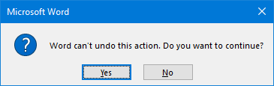

CROSS-REFERENCES TO HEADINGS, TABLES, FIGURES, NUMBERED PARAGRAPHS, ETC.
- Cross-references allow readers to navigate quickly within a document. Most report cross-references fall into the following categories: Numbered item, Heading, Footnote, Figure, and Table.
- To insert a cross-reference, click on “Cross-reference” in the Insert tab. Make selections from the “Reference type” and “Insert reference to” drop-down menus. Check the box for “Include above/below” if desired, and select “Insert as hyperlink.” Choose an item from the “For which numbered item” window.
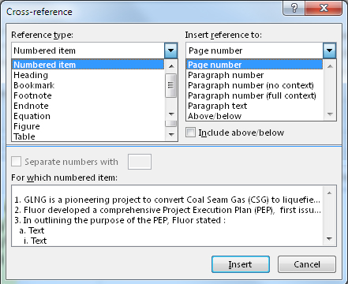
- Cross-references are “fields” in Word. To view fields, select File, then “Options” at the bottom left, then “Advanced.” Select “Always” next to “Field shading” and click OK. This makes it easier to see references. Give your references the “Cross Reference” style (see second image below).
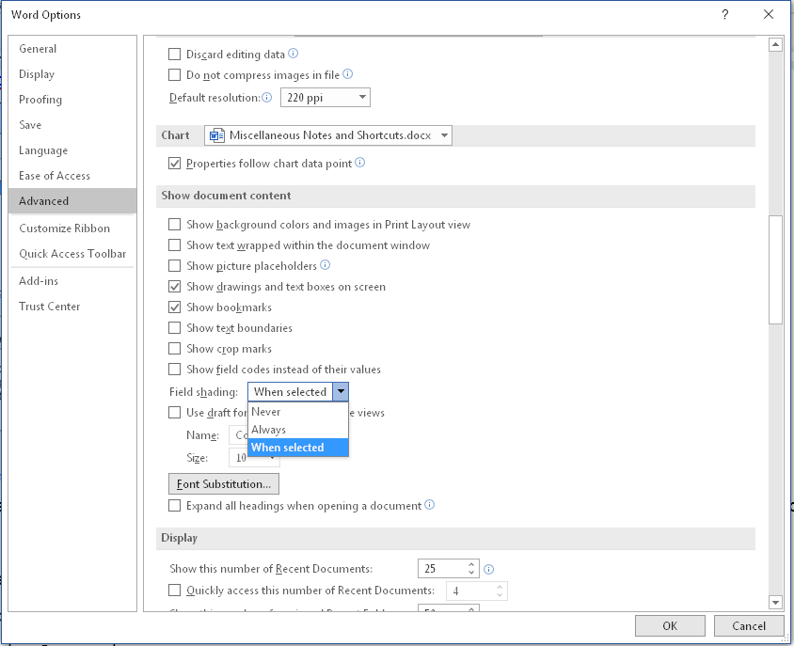
- In the first example below, Word highlights the field gray. The second example also includes the “Cross Reference” style.
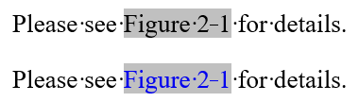
- When you see a cross reference in a document, hold down the Ctrl key and click on the field. This will take you to the referenced location. To learn more about cross references in Word, visit this webpage: https://support.microsoft.com/en-us/office/create-a-cross-reference-300b208c-e45a-487a-880b-a02767d9774b
- There are various ways to view tracked changes and comments in a document, including specifying which reviewers’ markup you wish to see. For more details about your options in the Review tab, visit this webpage: https://erinwrightwriting.com/view-specific-reviewers-comments-and-edits-in-microsoft-word/

ADDITIONAL CHECKS
- The following is a list of items to check when reviewing our reports:
Centering Tables, Figures, and Table and Figure Titles. The position of tables and figures on a page depends on whether numbered paragraphs are used and the width of the table or figure. If numbered paragraphs are used, then position the table or figure with a left-hand margin indented an additional 0.5" so that the table or figure is centered under the text, which also starts with a 0.5" left indent following the number of the paragraph. Visually, this position looks better. However, if the table or figure needs to be the full width of the page, i.e., for larger tables and figures, do not indent 0.5" on the left even if using numbered paragraphs. If numbered paragraphs are not used, then center the table or figure without any additional left indent.
Use of the word “this” without a noun after it. Often, the missing noun leaves the reference unclear. For example, “This has caused a problem” becomes “This misunderstanding has caused a problem.”
Capitalization of the word “Report.” Capitalize “Report” when referring to the subject Report.
Capitalization of “Project.” Capitalize “Project” when referencing the Project for which the Report is written. Also capitalize “Project” when it follows the name of the Project, such as the OL3 Project. Do not capitalize “project” when it is a modifier to another word, such as the project record, project costs, project schedule (unless a formal contract term), etc.
When using a colon preceding a list, and then a series of bullets or numbers follows the colon, use semicolons at the end of each listed item, with a “; and” following the penultimate item, and a period after the last item.
Footnotes: Check for periods at the end of each footnote and remove a line space after the footnote if one exists.
Use spell check.
Double periods. Often an extra period is inserted by mistake.
Extra spaces between words. Word usually inserts a green mark under the words when this happens.
Acronyms. If there is an acronym in parenthesis following the first usage of a word or phrase, then use that acronym thereafter in the report.
Appendices. Create separate files for appendices to the report. Otherwise, the table of contents needed for each appendix will not be created properly.
Line spacing. Decide up front if the report will be single or 1.5 line spacing in its final form. Beginning writing with the agreed-upon spacing reduces editing time later. Single line spacing is preferred.
Use of the word “below.” When referencing something below a paragraph, use a period after the word “below” and not a colon. For example, “The sum of the claims is $2,121,220, as seen in Table 2-2 below.”
“Since” vs. “Because.” The word “since” can act as an adverb or a conjunction. In either case it can mean “from a certain time in the past until the present” or “after a certain time in the past.” “Because” is a conjunction that can introduce an explanation or a reason for something. Traditionally, there was a distinction between “since” and “because”; however, they are often used interchangeably. When you write “since,” there may be ambiguity as to whether you are using the time meaning or the reasoning meaning. “Because” only has the reasoning meaning and therefore may be clearer when you want to communicate reasoning. Thus, please use “because” instead of “since” when you mean to give an explanation or reason for something.
“All of the.” For example: “All of the necessary explanations are included.” It is unnecessary to insert the word “of” in this sentence.
Man-hours. We typically use a hyphen in “man-hours” unless it appears in a quote that does not use the hyphen.
Use of id., ibid. In scholarly legal work (and perhaps other disciplines), “id” (Latin, short for “idem” and “eadem,” “the same”) refers to another page in the previous citation. Ibid., (Latin, short for “ibidem,” meaning “the same place”) refers to the exact same location in the previous citation. Example:
Roe v. Wade, 410 U.S. 113, 120 (1973).
Id. at 122. (not Ibid. at 122)
but,
Roe v. Wade, 410 U.S. 113, 120 (1973).
Ibid. (not Id.)
Id. at 122. (now referring to a different paragraph than the first citation)
Ibid. (if you were to cite again to 122)
- Refer to Long International, Inc., as “Long International, Inc.” the first time it appears in Section I of the expert report, and as “Long International” thereafter in Section I and all subsequent sections. To save time when preparing your draft narrative, it is acceptable (and preferable) to use “LI” in lieu of “Long International.” “LI” can be easily replaced with “Long International” using Word’s “Find and Replace” feature.
- When referring to the size of a pipe, fitting, etc., use for example “30-inch” rather than 30" unless the reference is part of an excerpt or quote.
- The first time you use an abbreviation or acronym, fully spell out all the words and immediately follow them with the acronym in parentheses. For example, “Pennsylvania Department of Environmental Protection (PADEP).”
- Primarily use past-tense verbs to state what we or someone has done. Example: “Long International’s review was limited to” instead of “Long International’s review is limited to.” However, for stating opinions, use the present tense: “It is Long International’s opinion that ...”
- For dates, use the DD Month YYYY format to avoid any confusion. 3 April 2011 is unambiguous, whereas 3/4/11 could be a date in either March or April, depending on whether the reader is used to a U.S. or European format. Do not use zeros before days 1–9 of the month (e.g., 03 April 2011) unless the reference is part of an excerpt or quote.
- Use commas after the penultimate word in a list. For example: “The authors are Messrs. Lane, Carter, and Bolin” rather than “The authors are Messrs. Lane, Carter and Bolin.”
- Use attachment numbers for documents prepared by Long International (e.g., worksheets, tables, figures, schedules, graphics, narratives, resumes/CVs, etc.) that are not incorporated into the narrative of the report.
- Use exhibit numbers for documents that were prepared by others, such as documents used in the subject project, articles, or internet-sourced documents.
- Capitalize the first word in a bulleted list unless it is a continuation of the preceding sentence. For example: The following items were excluded from the report:
    - Footnotes;
    - Description of Acronyms; and
    - List of Exhibits.
- Another example: The author forgot to include in his report:
    - footnotes;
    - a description of acronyms; and
    - a list of exhibits.
- If a bulleted list includes short phrases or single words, then do not use spaces between bullets and do not use semicolons. For example: The colors of the photograph include:
    - Blue
    - Green
    - Red
- The list above with single words does not require a semicolon after each word. If there are multiple words for each bullet, then use a semicolon after each item, and then use a semicolon followed by an “and” after the penultimate item in the list. For example: Non-Compensable Impacting Events include the following:
    - Permit-related delays;
    - Delayed start of construction;
    - Work sequencing and re-sequencing; and
    - Deficient work and rework.
- If a bulleted list is a sentence or uses more than one line for each bullet, then use the style “List bullet as a sentence,” which puts a space between each bulleted item. For example: The following impacts negatively affected ULS’ progress on the Project:
PVR issued a Contract Modification, which added a significant amount of work to ULS’ scope of work;
ULS was required to complete a substantial amount of Extra Work; and
In addition to the scope of work added by the Contract Modification, PVR added, late in the Project, two additional laterals to ULS’ scope of work.
- To form the possessive of a word or acronym ending in the letter “s,” add an apostrophe after the “s” but do not add another “s”; for example, the possessive form of ULS is ULS’, not ULS’s.
- To form the plural of an abbreviation or acronym, type the final pluralizing “s” as lower case without an apostrophe. For example, the plural of P&ID is written as P&IDs, not P&ID’s. The exception to this rule is that an apostrophe is necessary to pluralize an abbreviation that contains both uppercase and lowercase letters or that contains two or more interior periods; for example, M.A.’s and Ph.D.’s.
- Use the word “which” after a comma when the phrase after “which” explains what goes before the comma. If there is no comma, use “that” rather than “which.” For example, write “The document, which is self-explanatory, describes the events” or “The document that describes the events is self-explanatory.”
- Use “who” as the pronoun referring to a person, not “that.” For example, write “The person who I saw was Dr. Smith,” not “The person that I saw was Dr. Smith.”
- Avoid using pronouns such as “he,” “she,” or “it” if there may be uncertainty about who that person is.
- The word “farther” relates to distance. Examples: “If he walks farther into the woods, he might come upon a bear.” “Don’t go farther down the wrong path.” “New York is farther from Dallas than is Houston.” The word “further” relates to degree. Examples: “If he studied the matter further, he would understand.” “Further to our initial Report’s findings, we have now performed analyses that confirm this statement.” “Our conclusions require no further analysis.”
- Avoid using the word “this” to start a sentence or phrase without also including a noun or phrase after the word “this” to ensure the reader knows the intended reference. For example, instead of writing “This is incorrect,” write “This terminology is incorrect.” If the meaning of a quoted sentence is unclear, use context or brackets to clarify.
- When referring to a company, the verb and related pronoun should be singular. For example, “PVR is a good client, and its people have relied on our expertise” rather than “PVR are a good client, and their people have relied on our expertise.”
- Minimize use of the phrase “in order to.” The words “in order” are superfluous. “In order to” means the same thing as “to.”
- Use a singular pronoun with a singular subject. Incorrect: “Each person should take their own precautions.” Correct: “Each person should take his own precautions.” One might want to say, “Each person should take his or her own precautions.” However, the general rule is that “his” can be used when the gender is mixed or unknown.
- Avoid split infinitives (separating the word “to” from the verb that goes with it). For example, write “The parties agreed to settle the dispute amicably,” not “The parties agreed to amicably settle the dispute.”

29R-03, Section 1.5.B.6, Delay Must Affect the Critical Path, p. 18.
Type a tab here at the bottom of the page immediately after the footnote number. This ensures proper alignment of footnotes. To make sure you can see the tab mark, press the ¶ icon in the Home tab ribbon. Do not hit the space bar to indent the text.
Document First Partial Award in ICC Case No 22532/PTA (22972/PTA), 12 December 2017 (First Partial Award), para. (2)(c)(ii)–(iii), p. 50 of 53. [C-0050]

